**Title**

Attendance

**Description**

The School Attendance App is designed to streamline the process of tracking and managing student attendance in educational institutions.

By leveraging the power of mobile technology, this app aims to simplify attendance monitoring, enhance communication between parents and teachers, and improve overall school administration efficiency.

**Features**

1. Attendance Tracking:
   * Secure and real-time attendance recording for students.
   * Quick and easy marking of absent, present, and late students.
   * Integration with existing student information systems for seamless data synchronization.
   * Automatic generation of attendance reports for teachers and administrators.
2. Parent Communication:
   * Instant notifications to parents regarding their child's attendance status.
   * Alerts for absences, tardiness, and other attendance-related matters.
   * Two-way messaging system for effective communication between parents and teachers.
   * Access to attendance records and history to keep parents informed and engaged.
3. Reporting and Analytics:
   * Comprehensive attendance reports for administrators, teachers, and parents.
   * Data visualization tools to analyze attendance trends and patterns.
   * Identification of high-risk students with poor attendance records.
   * Customizable reports to meet specific school requirements.
4. Timetable Integration:
   * Synchronization with the school's timetable for automatic class and subject selection during attendance marking.
   * Ability to handle multiple timetables for different grade levels or campuses.
   * Automatic adjustment of attendance periods based on timetable changes or special events.
5. Security and Privacy:
   * Robust security measures to protect student data and ensure privacy compliance.
   * User authentication and authorization to restrict access to authorized personnel only.
   * Data encryption during transmission and storage.

**Benefits**

1. Efficient Attendance Management:
   * Eliminates manual paper-based attendance processes, reducing administrative workload and errors.
   * Simplifies attendance recording and tracking, saving teachers' time for more valuable activities.
   * Provides accurate and up-to-date attendance information for teachers, administrators, and parents.
2. Improved Parent Involvement:
   * Enhances parent-teacher collaboration and communication.
   * Keeps parents well-informed about their child's attendance, promoting proactive engagement.
   * Enables parents to address attendance issues promptly and support their child's academic progress.
3. Data-Driven Insights:
   * Enables schools to identify attendance patterns, intervene early, and take necessary actions.
   * Facilitates data analysis to understand the impact of attendance on student performance.
   * Supports evidence-based decision-making for attendance improvement strategies.
4. Enhanced Accountability:
   * Enables tracking of teacher attendance to ensure staff accountability.
   * Facilitates auditing and compliance with attendance policies and regulations.
   * Provides transparent attendance records to address potential disputes or conflicts.

**UML symbols**

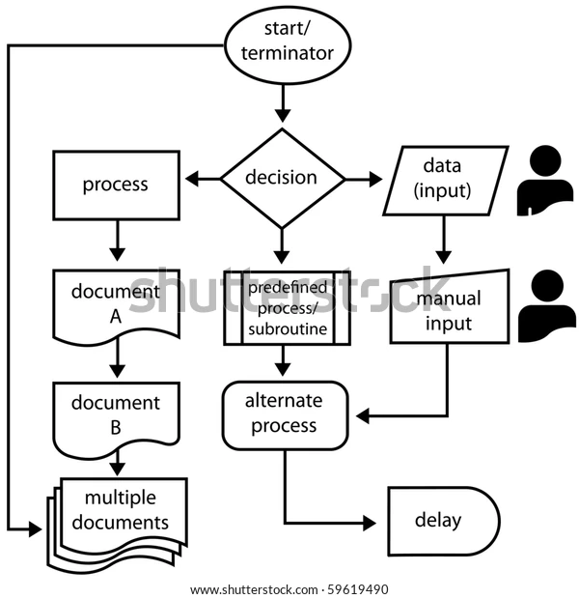

|  |  |  |
| --- | --- | --- |
| **ANSI/ISO Shape** | **Name** | **Description** |
|  | Flowline (Arrowhead)[[15]](https://en.wikipedia.org/wiki/Flowchart#cite_note-Myler1998-15) | Shows the process's order of operation. A line coming from one symbol and pointing at another.[[14]](https://en.wikipedia.org/wiki/Flowchart#cite_note-ShellyVermaat2011-14) Arrowheads are added if the flow is not the standard top-to-bottom, left-to right.[[15]](https://en.wikipedia.org/wiki/Flowchart#cite_note-Myler1998-15) |
|  | Terminal[[14]](https://en.wikipedia.org/wiki/Flowchart#cite_note-ShellyVermaat2011-14) | Indicates the beginning and ending of a program or sub-process. Represented as a [stadium](https://en.wikipedia.org/wiki/Stadium_(geometry)),[[14]](https://en.wikipedia.org/wiki/Flowchart#cite_note-ShellyVermaat2011-14) oval or rounded (fillet) rectangle. They usually contain the word "Start" or "End", or another phrase signaling the start or end of a process, such as "submit inquiry" or "receive product". |
|  | Process[[15]](https://en.wikipedia.org/wiki/Flowchart#cite_note-Myler1998-15) | Represents a set of operations that changes value, form, or location of data. Represented as a [rectangle](https://en.wikipedia.org/wiki/Rectangle).[[15]](https://en.wikipedia.org/wiki/Flowchart#cite_note-Myler1998-15) |
|  | Decision[[15]](https://en.wikipedia.org/wiki/Flowchart#cite_note-Myler1998-15) | Shows a conditional operation that determines which one of the two paths the program will take.[[14]](https://en.wikipedia.org/wiki/Flowchart#cite_note-ShellyVermaat2011-14) The operation is commonly a yes/no question or true/false test. Represented as a diamond ([rhombus](https://en.wikipedia.org/wiki/Rhombus)).[[15]](https://en.wikipedia.org/wiki/Flowchart#cite_note-Myler1998-15) |
|  | Input/Output[[15]](https://en.wikipedia.org/wiki/Flowchart#cite_note-Myler1998-15) | Indicates the process of inputting and outputting data,[[15]](https://en.wikipedia.org/wiki/Flowchart#cite_note-Myler1998-15) as in entering data or displaying results. Represented as a [rhomboid](https://en.wikipedia.org/wiki/Rhomboid).[[14]](https://en.wikipedia.org/wiki/Flowchart#cite_note-ShellyVermaat2011-14) |
|  | Annotation[[14]](https://en.wikipedia.org/wiki/Flowchart#cite_note-ShellyVermaat2011-14) (Comment)[[15]](https://en.wikipedia.org/wiki/Flowchart#cite_note-Myler1998-15) | Indicating additional information about a step in the program. Represented as an open rectangle with a dashed or solid line connecting it to the corresponding symbol in the flowchart.[[15]](https://en.wikipedia.org/wiki/Flowchart#cite_note-Myler1998-15) |
|  | Predefined Process[[14]](https://en.wikipedia.org/wiki/Flowchart#cite_note-ShellyVermaat2011-14) | Shows named process which is defined elsewhere. Represented as a rectangle with double-struck vertical edges.[[14]](https://en.wikipedia.org/wiki/Flowchart#cite_note-ShellyVermaat2011-14) |
|  | On-page Connector[[14]](https://en.wikipedia.org/wiki/Flowchart#cite_note-ShellyVermaat2011-14) | Pairs of labeled connectors replace long or confusing lines on a flowchart page. Represented by a small circle with a letter inside.[[14]](https://en.wikipedia.org/wiki/Flowchart#cite_note-ShellyVermaat2011-14)[[18]](https://en.wikipedia.org/wiki/Flowchart#cite_note-RFF-18) |
|  | Off-page Connector[[14]](https://en.wikipedia.org/wiki/Flowchart#cite_note-ShellyVermaat2011-14) | A labeled connector for use when the target is on another page. Represented as a [home plate](https://en.wikipedia.org/wiki/Baseball_field#Home_base)-shaped [pentagon](https://en.wikipedia.org/wiki/Pentagon).[[14]](https://en.wikipedia.org/wiki/Flowchart#cite_note-ShellyVermaat2011-14)[[18]](https://en.wikipedia.org/wiki/Flowchart#cite_note-RFF-18) |

**Other symbols**[[edit](https://en.wikipedia.org/w/index.php?title=Flowchart&action=edit&section=6)]

The ANSI/ISO standards include symbols beyond the basic shapes. Some are:[[17]](https://en.wikipedia.org/wiki/Flowchart#cite_note-IBM1970-17)[[18]](https://en.wikipedia.org/wiki/Flowchart#cite_note-RFF-18)

|  |  |  |
| --- | --- | --- |
| **Shape** | **Name** | **Description** |
| [Flowchart database](https://en.wikipedia.org/wiki/File:Flowchart_database.svg) | Data File or Database | Data represented by a [cylinder](https://en.wikipedia.org/wiki/Cylinder) symbolizing a disk drive. |
| [Flowchart Document](https://en.wikipedia.org/wiki/File:Flowchart_Document.svg) | Document | Single documents represented as a [rectangle](https://en.wikipedia.org/wiki/Rectangle) with a wavy base. |
| [Flowchart Document multiple](https://en.wikipedia.org/wiki/File:Flowchart_Document_multiple.svg) | Multiple documents represented as a stack of rectangles with wavy bases. |
| [Flowchar Manual input](https://en.wikipedia.org/wiki/File:Flowchar_Manual_input.svg) | Manual operation | Represented by a [trapezoid](https://en.wikipedia.org/wiki/Trapezoid) with the longest parallel side at the top, to represent an operation or adjustment to process that can only be made manually. |
| [Flowchart manual input](https://en.wikipedia.org/wiki/File:Flowchart_manual_input.svg) | Manual input | Represented by [quadrilateral](https://en.wikipedia.org/wiki/Quadrilateral), with the top irregularly sloping up from left to right, like the side view of a [keyboard](https://en.wikipedia.org/wiki/Computer_keyboard). |
| [Flowchart Preparation](https://en.wikipedia.org/wiki/File:Flowchart_Preparation.svg) | Preparation or Initialization | Represented by an elongated [hexagon](https://en.wikipedia.org/wiki/Hexagon), originally used for steps like setting a switch or initializing a routine. |